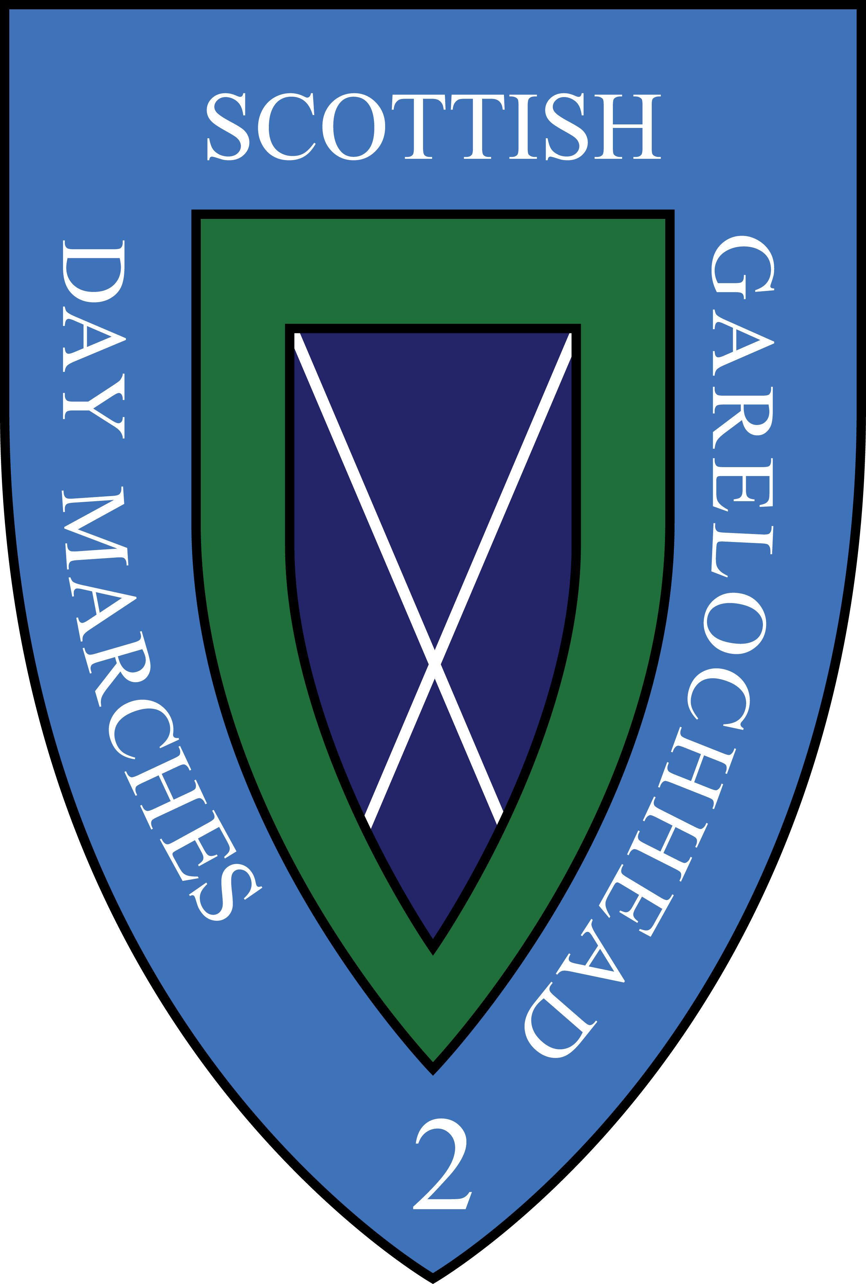

Scottish Garelochhead 2 Day Marches
29th / 30th April 2023

PHOTOGRAPHIC PERMISSION

From: (Please enter your team name)………………………………………………….

This is to confirm that permission is granted for photographs / videos to be taken which may be used for publicity purposes by Scottish Garelochhead Marches.

Team Leader…………………………………………………………….

Cadet Teams

Should any Cadet Team member be under 16 at 30th April 2023 then separate written permission is required from parents or guardians, and this is the responsibility of the Team Leader to obtain, and attach to this form.

